**Lab Assessment-8**

Q)

public class PrintEvenOddTester {

public static void main(String... args) {

Printer print = new Printer();

Thread t1 = new Thread(new TaskEvenOdd(print, 10, false));

Thread t2 = new Thread(new TaskEvenOdd(print, 10, true));

t1.start();

t2.start();

}

}

class TaskEvenOdd implements Runnable {

private int max;

private Printer print;

private boolean isEvenNumber;

TaskEvenOdd(Printer print, int max, boolean isEvenNumber) {

this.print = print;

this.max = max;

this.isEvenNumber = isEvenNumber;

}

@Override

public void run() {

//System.out.println("Run method");

int number = isEvenNumber == true ? 2 : 1;

while (number <= max) {

if (isEvenNumber) {

//System.out.println("Even :"+ Thread.currentThread().getName());

print.printEven(number);

//number+=2;

} else {

//System.out.println("Odd :"+ Thread.currentThread().getName());

print.printOdd(number);

// number+=2;

}

number += 2;

}

}

}

class Printer {

boolean isOdd = false;

synchronized void printEven(int number) {

while (isOdd == false) {

try {

wait();

} catch (InterruptedException e) {

e.printStackTrace();

}

}

System.out.println("Even:" + number);

isOdd = false;

notifyAll();

}

synchronized void printOdd(int number) {

while (isOdd == true) {

try {

wait();

} catch (InterruptedException e) {

e.printStackTrace();

}

}

System.out.println("Odd:" + number);

isOdd = true;

notifyAll();

}

}

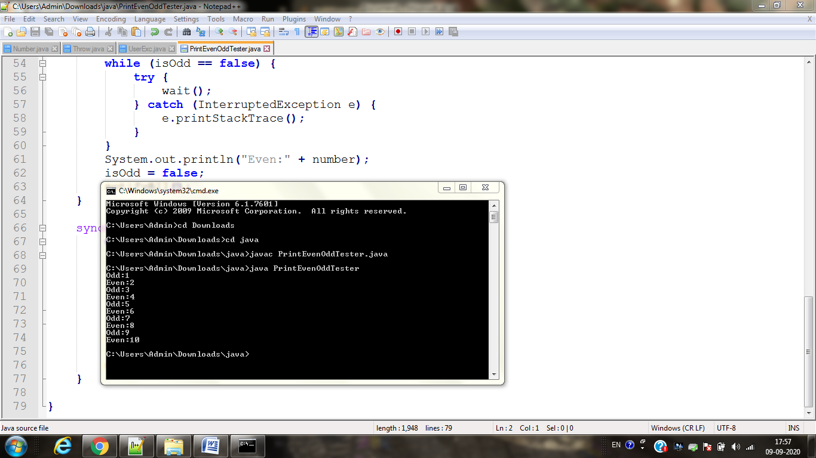

Q)

class ThreadExample extends Thread

{

ThreadExample(String s)

{

super(s);

start();

}

public void run()

{

for(int i=0;i<5;i++)

{

System.out.println(Thread.currentThread().getName());

try

{

if(Thread.currentThread().getName()=="Hello")

{

Thread.sleep(2000);

}

else

{

Thread.sleep(4000);

}

}

catch(Exception e){}

}

}

}

class MainMsg

{

public static void main(String arg[])

{

System.out.println("Thread name : "+Thread.currentThread().getName());

ThreadExample e1=new ThreadExample("Hello");

ThreadExample e2=new ThreadExample("Welcome to VIT");

}

}

